JUICE reporting features

Student activity overview 1

Try it item analysis 4

Detailed records review 10

Filtering the records data 11

Understanding the raw json 13

Searches and Feedback reports 16

# Student activity overview

JUICE tracks detailed information about student activity in the site. The Student activity overview is a spreadsheet report that summarizes a student’s activity in a specific mini-lesson, on a specific day.

To access the report:

* + - 1. Follow the instructions in the documentation *Accessing JUICE* about logging in to the site using the test page, and log in as Alistair Admin.
      2. After JUICE has loaded, put this URL into the JUICE tab, OR open a new window in the same browser and put this URL into it:

<https://[juice> site]/juice/report

* + - 1. This will load the report request form:

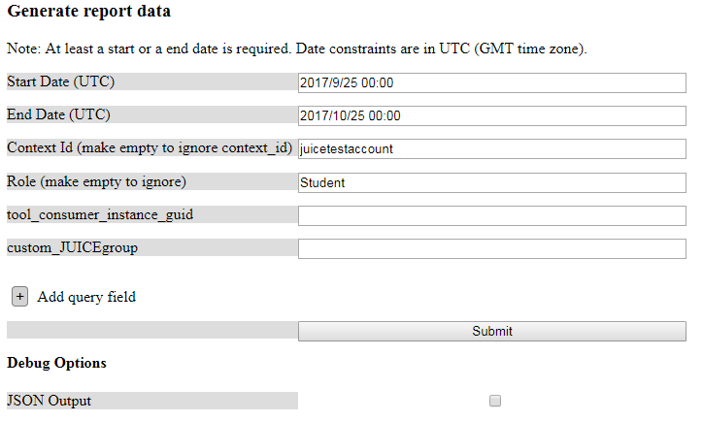

* + - 1. Fill out the form to generate the data you are interested in.   
         1. The Start and End Dates define the date range during which users accessed JUICE. Clicking the Date fields will give you a calendar to choose your date from.
         2. The context id can be used to specify the cohort of students you are looking at.
         3. Use Role to specify Student, Coach, Admin, Reviewer etc.
         4. Tool_consumer_instance_guid can be used to define an institution level cohort. This value is passed as an LTI launch parameter, or can be defined as part of a social log-in access code.
         5. custom_JUICEgroup can be used to generate data for custom groups of students. This value can be passed as an LTI launch parameter, or can be defined as part of a social log-in access code.

Note: See the documentation *Accessing JUICE* for more information about LTI or social log-in access codes.

* + - 1. If you wish to filter data based on fields that are not showing, click on the + Add query field button. This will add a field that looks like this:

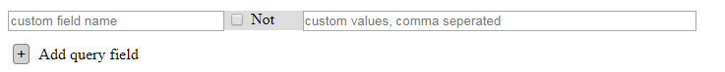

Enter a field name, and the values you wish to filter on. You can use this to search on multiple values. For example, you can use it to find data for the roles Student and Learner:

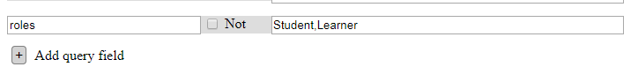

You can use the “Not” function to exclude a set of values from the data. This will exclude records for students with these two ids:

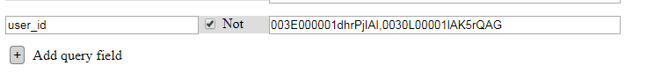

See below for a list of the fields you can search on.

* + - 1. After you fill out the form, click Submit, and a spreadsheet of data summarizing JUICE activity will download to your computer. The data is organized with one user’s access to a specific mini-lesson in one day per row. A user that has accessed more than one mini-lesson in a day will have multiple rows for that day.

The data provided is this:

* User ID
* Date and time the mini-lesson was first accessed that day
* Duration of time spent in that mini-lesson for that day in seconds
* Project that the student crossed to JUICE from (Only relevant if your integration includes this information in the launch)
* Module ID
* Mini-lesson id
* User role
* Overview—date and time of first access
* Overview—time spent in seconds
* Overview—number of accesses to the same overview that day
* Overview—whether the student got past the first step
* Overview—whether the student completed the Overview

This information is provided for the Overview then repeats for each of the 3 Try its, and each of the 3 Challenge games. The last 5 columns provide this same information when a student accesses a Challenge Wheel game.

### Searchable fields

user_id

short_user_id

program_id

last_updated

custom_source

context_id

roles

custom_JUICEgroup

tool_consumer_instance_guid

widget_name

widget_data_file

complete

modulette_name

tab_id

track_id

started

module_id

modulette_id

competencies

competencies_id

subcompetencies

subcompetencies_id

duration_ms

# Try it item analysis

JUICE provides summary information about student activity in the Try its if you are logged in to the site as an administrator. To access this:

* + - 1. Follow the instructions in the documentation *Accessing JUICE* about logging in to the site using the test page, and log in as Alistair Admin.
      2. Navigate to the Try it you are interested in.
      3. Click the link that says “Report” in the upper left corner of the Try it to load the Try it report. If you right click and choose “Open in a new window” you can review the report and the Try it at the same time.

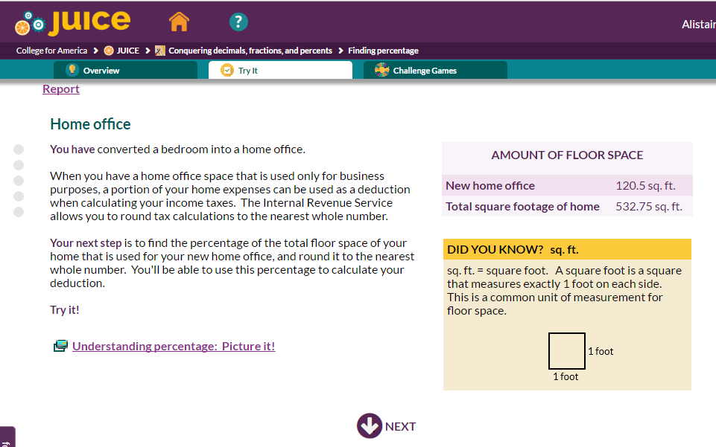

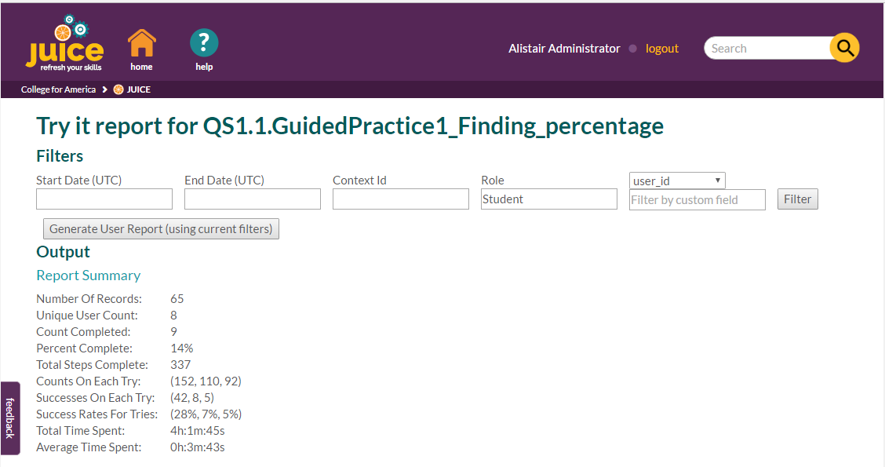

The top section of the report allows you to filter the data you are looking at as follows:



| **Filter** | **What it does** |
| --- | --- |
| Start and End Date | This defines the date range for the student activity you will view.  The time is in UTC, which is the same as Greenwich Mean Time. |
| Context ID | This is the value passed to JUICE on the lti launch as the “context_id.” It is most often some kind of course id. |
| Role | User role. This could be Student, Coach, Reviewer, Learner, Educator, Administrator, etc. |
| Filter by custom field | The last filter field allows you to choose one of 4 criteria to filter on.  _id: This is the id of the Try it attempt. Used for debugging.    user_id: Use this to see all the records for a specific student  custom_source: For College of America students, this is the id of the project that the student launched JUICE from.  complete: Whether or not the student worked all the way through the “Try it”. Set this to “true” if you want to see only records for attempts that the student worked completely through. |

Underneath the filter area is a button that allows you to generate an item analysis report using the filter settings.

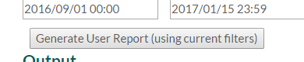

This is downloaded to your computer as a spreadsheet and shows a row of information for each Try it access. Each row has:

* user id
* user first and last name
* date and time that the student started the Try it.

The remaining columns show the number of the “try” when the student answered correctly for each interaction in the Try it:

1. = answered correctly on first try
2. = answered correctly on second try
3. = answered correctly on third try
4. = never answered correctly and was shown the answer.

blank = did not attempt



The next section of the report is summary data:

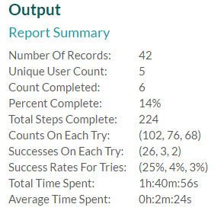

| **Data** | **Description** |
| --- | --- |
| Number of records | The number of attempts to work the Try it that are being counted in the report based on your filter settings. |
| Unique User Count | Unique number of students included in the count. In the example above, 5 students attempted the Try it a total of 42 times—one or more of them attempted it more than once.  (This is test data! In a real example, the number of unique students and number of records would be closer.) |
| Count completed | Number of attempts for which the student worked completely through the Try it and got to the last step. |
| Percent Complete | Complete divided by Number of Records |
| Total Steps Complete | Total number of steps worked by students |
| Counts on Each Try | Across all the Try its and all the interactions, the number of first try attempts, second try attempts, and third try attempts |
| Success on Each Try | Across all the Try its and all the interactions, the number of attempts that were correct on the first try, second try, and third try. |
| Success Rates for Tries | Across all the Try its and all the interactions, the percentage of first try attempts that were correct, the percentage of section try attempts that were correct, the percentage of third try attempts that were correct. |
| Total Time Spent | Total time spent by the students working the Try it |
| Average Time Spent | Average time spent across all the records included in the filter |

The summary is followed by the question breakdown. This shows a truncated version of each step in the Try it. Some steps do not have any questions.

For steps with questions, the question breakdown shows the id of the question within the truncated text, followed by a summary of how students answered on the first, second, and third try.

This is accompanied by tables showing how many students chose each answer choice on the first, second, and third try. Student answer choices are truncated also, but you can see the full text of student answers by rolling over the answer choices.

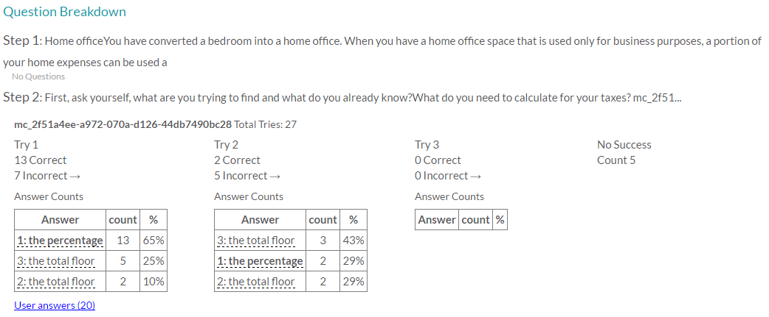

Number of correct and incorrect attempts on each try.

Question id.   
“mc” indicates that this is multiple choice or multi select. IDs with “sa” indicate short answer interactions

Number and percentage of students selecting each answer. The correct answer is in bold. Roll over the answer choice to see the full text.

Click the User answers link to view a list of how each student answered. This will open on the same page and can be closed by clicking the link again.

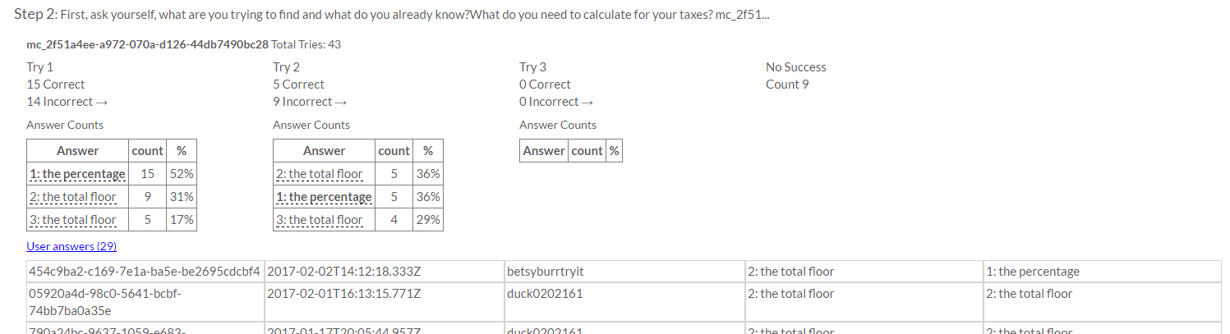

In this example, student betsyburrtryit answered “the total floor. . .” on the first attempt, and “the percentage. . .” on the second attempt.

# Detailed records review

JUICE tracks every student action in each mini-lesson part. You can view the raw data logged in as Alistair Admin.

* + - 1. Follow the instructions above to log in to the site as Alistair Admin
      2. After JUICE has loaded, put this URL into the JUICE tab, OR open a new window in the same browser and put this URL into it:

<https://[juice> site]/juice/records

1. This loads a page of raw json data:

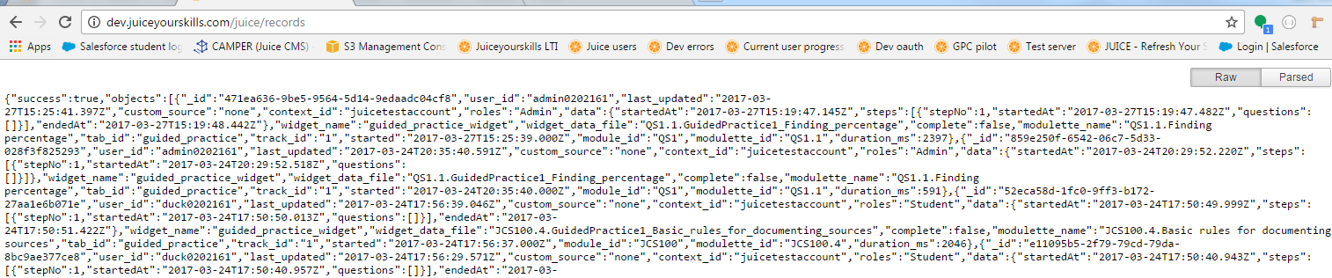

You need to install a json parser in order to be able to view this data nicely formatted on screen. Both Chrome and Firefox have json parsers available as browser add-ons.

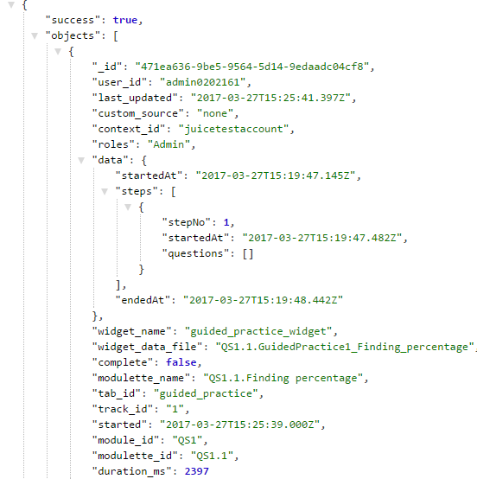

You can also copy and paste the raw data into online tools that will parse it for you. Two of the JUICE team’s favorites are:

<http://www.freeformatter.com/json-formatter.html#ad-output>

<https://konklone.io/json/>

## Filtering the records data

By default, the records view will show you the most recent 100 JUICE records. You can change the number of records displayed by adding a parameter in a query stringto the end of the URL:

[/juice/records?limit=1000](https://www.juiceyourskills.com/juice/records/1000)

You can also filter the records by adding other parameters to the query string in this format:

?$[parameter name]=value

Or

?$[parameter name]=!value    where ! means NOT

Multiple parameters can be added using “&”

Multiple values for the same parameter can be included in a value delimited list.   Each value in the list represents an “AND.” Note: This is only useful for “NOT” queries.

Parameters and values are case sensitive. For example, if you’re querying for records based on module id the letters in the id must be capitalized (CS28CCT3 not cs28cct3)

Parameter names that can used in queries are as follows:

user_id

context_id

roles  (Student, Admin, Reviewer, Coach)

widget_name (Eg: guided_practice_widget , refresher_widget, sorter_widget)

widget_data_file

module_id (CS16, QS1)

modulette_id (CS16.7, QS1.1)

Examples:

5 most recent records for betsyburr that show refresher widget results:

/juice/records?$user_id=betsyburr&$widget_name=refresher_widget&limit=5

5 most recent records for users who are NOT betsyburr that show refresher widget results:

/juice/records?$user_id=!betsyburr&$widget_name=refresher_widget&limit=5

100 most recent records for users who are NOT betsyburr and NOT betsyburrhes

/juice/records?$user_id=!betsyburr,!betsyburrhes

100 most recent records for users who are NOT betsyburr and NOT betsyburrhes and ARE refresher results:

    /juice/records?$user_id=!betsyburr,!betsyburrhes&$widget_name=refresher_widget

## Understanding the raw json

Each time a student accesses a widget (Refresher, Guided Practice, and Game content players), the widget stores data about what the student is doing in a record that JUICE calls a “widget session.” The widget sends the widget session data to the server when the student navigates from step to step, or from round to round in a game. When the student leaves the widget, the widget sessions ends.

The widget session data consists of session metadata and session data. This example shows the session metadata—the section of the record with the session data is collapsed.

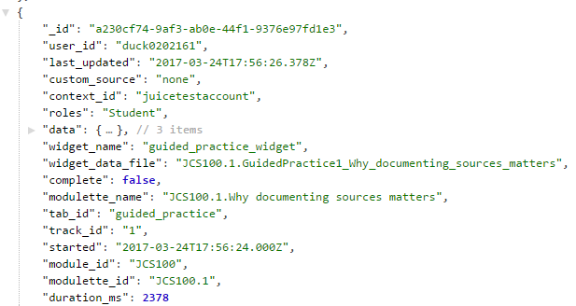

The session metadata is as follows:

| **metadata name** | **What it is** |
| --- | --- |
| _id | Id for the widget session |
| user_id | User’s id |
| last_updated | The last time the widget sent the data to the server |
| custom_source | For College for America users, this is the project from which the user launched JUICE |
| context_id | The context id is passed to JUICE in the JUICE launch |
| roles | User’s role |
| widget_name | Type of widget (refresher, guided practice, balancer, puzzler, etc.) |
| widget_data_file | Name of the content file that the widget is playing |
| complete | Whether or not the student clicked all the way through and got to the last step of a Refresher or Guided Practice, or got to the Scoreboard for a mini-game. |
| modulette_name | Associated modulette |
| tab_id | Which tab the widget loaded from |
| track_id | Which track the student accessed |
| started | When the student first accessed the widget |
| module_id | Associated module id |
| modulette_id | Associated modulette id |
| duration_ms | How long the widget session lasted in milliseconds. |

The session data saved by each widget varies, depending on the widget type, but it does follow the same basic format.

* Refreshers and Guided Practices save data for each widget **step**, while Challenge games save data for each widget game **round**.
* In a Challenge game, when a student decides to Play Again, the data from the new attempt is stored in the same widget session, so the data saved for each widget game round is grouped into “attempts.”
* All widgets save the data session start and end time, and also save the start and end time for each piece of data (step, attempt, or round).
* The Refresher saves data about the user’s audio usage on each step, and also indicates if a user chose to “See all steps.”
* Guided practices and Challenge games save detailed information about student interactions:
  + Student answers
  + Correct or incorrect status
  + Feedback received by a student

Here are a few examples:

Refresher

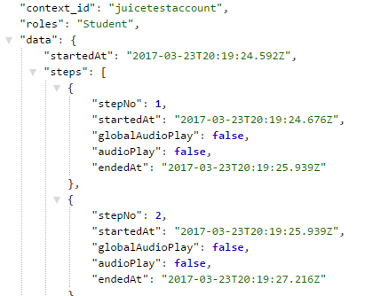

Guided Practice interaction

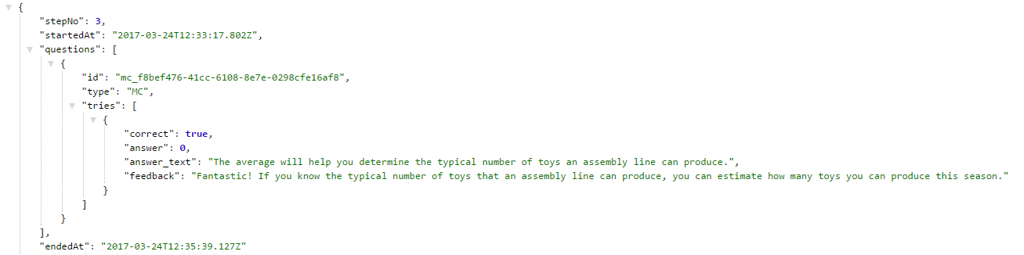

Balancer game interaction

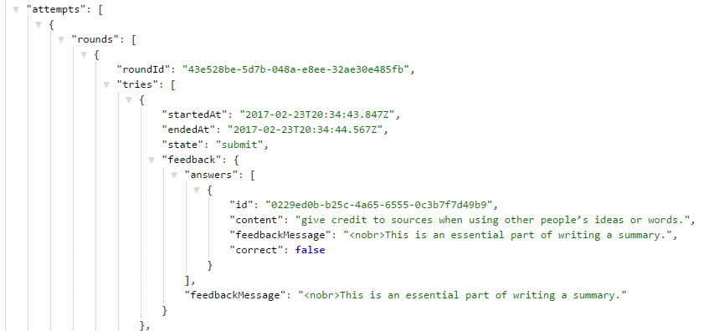

Challenge games will record a complete set of interaction data each time the student interacts with the game. For example, if a student submits an answer, and then choses “Clear Answers,” it will appear that the widget is recording the same data twice.

A widget session is considered “complete” after a user either gets to the summary step at the end of a Refresher or Guided Practice, or to the Scoreboard for a game. Once a challenge game widget session is “complete” it retains that status, even if the student starts a new attempt by clicking “Play Again” and does not finish it.

# Searches and Feedback reports

When you are logged in as an admin, you can see reports that show you what students are searching on, and if they have provided any feedback.

* + - 1. Follow the instructions above to log in to the site as Alistair Admin
      2. After JUICE has loaded, put this URL into the JUICE tab, OR open a new window in the same browser and put this URL into it:

<https://[juice> site]/juice/searches

This will load a records page that shows search terms, and whether we displayed any results.

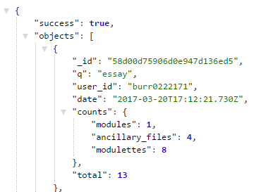

1. To view feedback that JUICE has received, use this URL.

<https://[juice> site]/juice/feedback

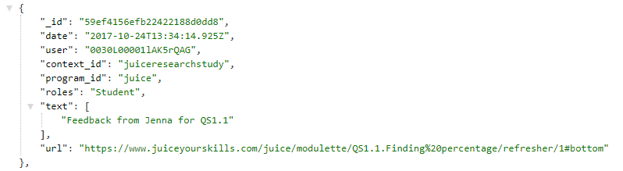

1. You can use the URL filters described above to see the records that you are interested in. Note: the filters will only work on the data that displays on the page.